# 应用场景

需要进行行转列的场景：

报表统计

汇总显示

需要进行列转行的场景：

属性拆分

ETL数据处理

# 操作

## 需求分析

我们需要实现如下的行列转换：

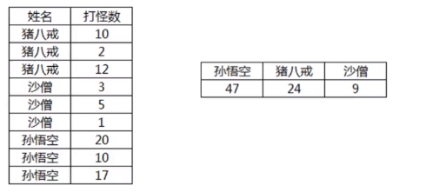

## 行转列

### 自连接实现

实现SQL：

SELECT * FROM (

SELECT sum(kills) as “孙悟空” FROM user1 a JOIN user_kills b

ON a.id=b.user_id and a.user_name=”孙悟空”

) a CROSS JOIN

SELECT sum(kills) as “猪八戒” FROM user1 a JOIN user_kills b

ON a.id=b.user_id and a.user_name=”猪八戒”

) b CROSS JOIN

SELECT sum(kills) as “沙僧” FROM user1 a JOIN user_kills b

ON a.id=b.user_id and a.user_name=”沙僧”

) c

;

使用这种方式缺点在于，join随着用户的数增加，执行效率不高，且SQL复杂。

### CASE方法实现

实现SQL：

SELECT sum(CASE WHEN user_name=”孙悟空” THEN kills END) as “孙悟空”

sum(CASE WHEN user_name=”猪八戒” THEN kills END) as “猪八戒”

sum(CASE WHEN user_name=”沙僧” THEN kills END) as “沙僧”

FROM user1 a JOIN user_kills b on a.id=b.user_id;

### 序列化表实现

实现SQL：

SELECT user_name

,REPLACE(SUBSTRING(SUBSTRING_INDEX(mobile,’,’.a.id),

CHAR_LENGTH(SUBSTRING_INDEX(mobile,’,’,a.id-1))+1),’,’,’’) AS mibile

FROM tb_sequence a

CROSS JOIN (

SELECT user_name

,CONCAT(mobile,’,’) AS

mobile,LENGTH(mobile)-LENGTH(REPLACE(mobile,’,’’’))+1 size

FROM user1 b

) b ON a.id<=b.size

;

## 列转行

### 单列转多行

### UNION实现

### 序列化表